**Iot based noise pollution monitoring**

Definition:

Noise Pollution in IoT refers to the presence of excessive and disruptive sound levels in the environment, which are typically caused by human activities and can adversely affect human health, wildlife, and the acoustic environment. IoT technologies are employed to monitor, measure, analyse, and mitigate noise pollution by collecting and processing data from various sensors and devices.

Problems:

Limited noise monitoring: Traditional noise monitoring methods are often limited in scope and accuracy, making it challenging to comprehensively assess noise pollution levels in urban areas or near industrial sites.

Solution: Deploy IoT-based noise sensors and networks to gather real-time noise data across various locations, enabling more precise monitoring and analysis.

Data Overload: IoT-based noise monitoring systems can generate vast amounts of data, making it difficult to process, analyse, and extract meaningful insights.

Solution: Implement data analytics and machine learning algorithms to process and interpret noise data efficiently, identifying trends, patterns, and potential issues.

Privacy Concerns: Noise monitoring using IoT may inadvertently capture private conversations or activities, raising privacy concerns.

Solution: Ensure that noise monitoring systems are designed and configured to focus on environmental noise rather than specific conversations or activities, and implement data anonymization techniques.

Data Accuracy: IoT sensors used for noise monitoring must be calibrated and maintained regularly to ensure accurate and reliable data.

Solution: Implement a calibration and maintenance schedule, with automatic alerts for sensor issues, and conduct periodic quality assurance checks.

Integration with Urban Planning: Noise pollution data collected through IoT should be integrated into urban planning processes to make informed decisions about land use, transportation, and infrastructure development.

Solution: Establish data-sharing mechanisms between IoT noise monitoring systems and urban planning authorities to inform policy and decision-making.

Noise Mitigation: IoT systems can also be used to implement noise mitigation measures, such as adaptive traffic management or noise barriers. However, these solutions may face challenges in implementation and effectiveness.

Solution: Conduct thorough assessments of the effectiveness of noise mitigation measures and adjust them as needed based on real-time data and feedback.

Community Engagement: Engaging with affected communities and stakeholders to address noise pollution concerns and implement appropriate solutions is crucial.

Solution: Foster community involvement through public awareness campaigns, feedback mechanisms, and collaborative decision-making processes.

Energy Consumption: IoT devices used for noise monitoring should be energy-efficient to reduce their carbon footprint.

Solution: Optimize IoT sensor design for low energy consumption, use renewable energy sources where possible, and employ energy-efficient data transmission protocols.

Regulatory Compliance: Ensure that noise monitoring systems and IoT solutions adhere to local and national regulations regarding noise pollution.

Solution: Collaborate with regulatory bodies and stay up-to-date with noise pollution regulations, ensuring that the IoT system complies with legal requirements.

By addressing these problems and defining noise pollution in the context of IoT, urban planners, environmental agencies, and communities can work together to create healthier and more sustainable urban environments with reduced noise pollution levels.

Component required:

ESP8266 NodeMCU Board

Microphone sensor

16*2 LCD Module

Breadboard

Connecting wires

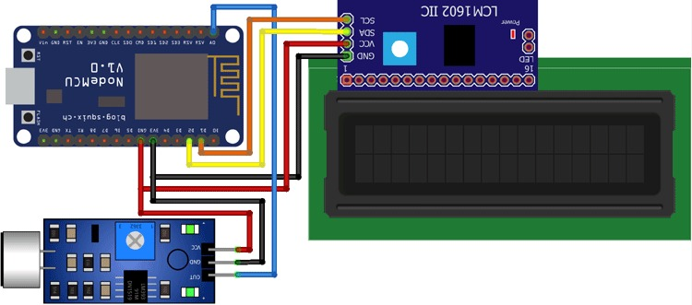Fig:Noise pollution monitioring